THE SURGICAL AIRWAY Rob Bryant MD

INCIDENCE: 1:200 AIRWAYS
WHO:
Anticipate need for cricothyrotomy in any patient, especially in patients with a predicted difficult airway.
CricCon scoring system (unvalidated) is helpful to guide level of preparedness.

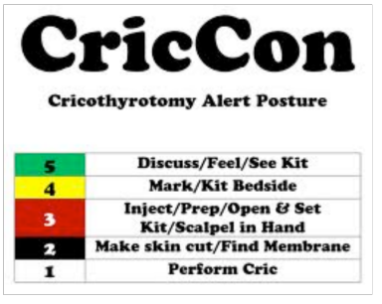www.emcrit.org Scott Weingart MD

WHEN:
CICV: Cannot Intubate, Cannot Ventilate.
Failed attempt vs failed airway
Failed Attempt: Placing laryngoscope in mouth without achieving a definitive airway.
Failed Airway: Three attempts at intubation (including attempt by most experienced provider) without securing airway; OR failure to maintain oxygenation / ventilation between attempts.

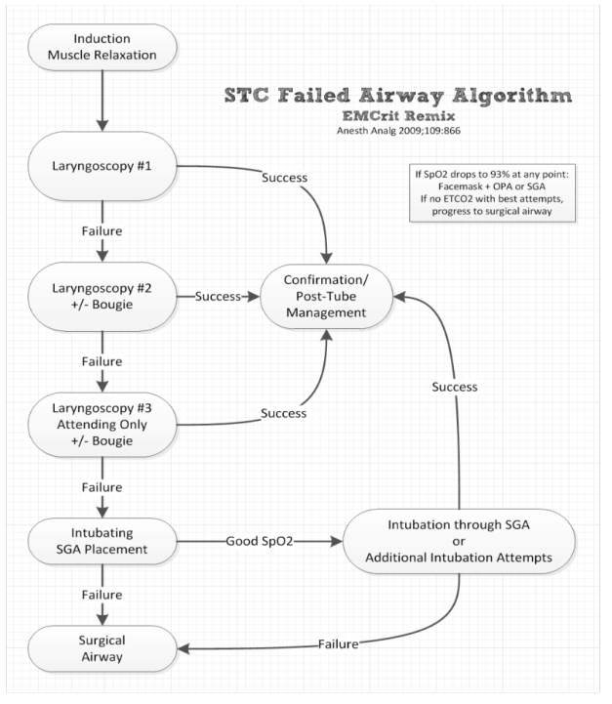
ANATOMY:
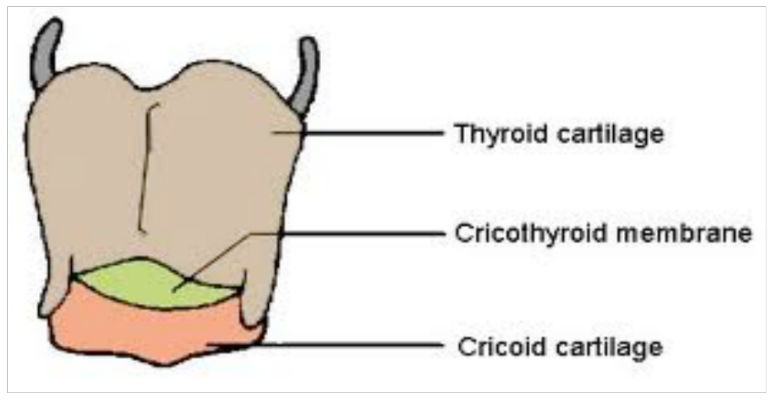
Key step is identification / palpation of cricoid cartilage.
FOUR FINGER TECHNIQUE:
Place pinky finger in sternal notch, cricoid should be under the index finger when all fingers placed on anterior neck.
LARYNGEAL HANDSHAKE:
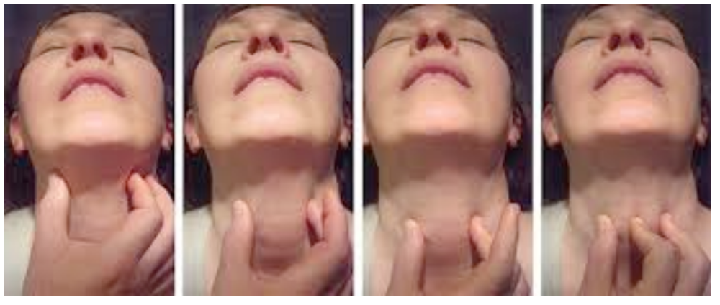

Palpate larynx from just under mandible, progressively moving down the neck and identifying the cricoid at the level of the lamina of the thyroid cartilage, and then placing index finger over cricothyroid membrane.

HOW:
Open / Surgical Cricothyrotomy
Vertical incision over cricothyroid membrane. Transverse incision through cricothyroid membrane. Place pinky finger through incision, then passage of bougie, then tube / trach. (Size 6.0 ETT, or size 6 Shiley) This is typically a ‘blind’ procedure due to the bleeding / urgency of situation.

Percutaneous Cricothrotomy
Similar to seldinger central line technique. Needle, wire, dilator, tube.
Slower than Open Cric. (Packet describes 11 steps)

Cricothyrotomy is a slow procedure that at its fastest, from betadine to tube placement can take 60 seconds, and with providers less experienced, or less prepared it could take as long as 2 minutes. It is best to start the cricothyrotomy with oxygen saturations > 85%, allowing the patient to be less hypoxic at the end of the procedure.

BARRIERS:
Human factors issues conspire against successful surgical airway interventions.
Graded Assertiveness:
It is hard to watch an airway death spiral where surgical airway is necessary but the decision to proceed has not been made.
Aviation term that is a work around for the hierarchical and cultural issues involves in challenging the authority of the team leader / airway provider
State Facts, State Concerns, Suggest an intervention.
Up the ante with each successive round of graded assertiveness so that on round three you can be very direct / authoritative.

NOT IF, BUT WHEN:
Cricothyrotomy should not be viewed as a failure, but as the next logical step in airway management.
Change mindset from: ‘if I am in a CICV situation I will perform a surgical airway’ to ‘when I am in a CICV situation I will perform a surgical airway’.

Rob Bryant MD
robjbryant13@gmail.com
@robjbryant13

