BUILDING A SALAD RECIRCULATING PUMP

Tools Needed:
Drill or Drill Press
⅛” Drill Bit
1 ¼” Drill Bit / Hole Saw
Channel Locks
Razor Knife
Belt Sander

Time Involved : 5 Minutes

Recommended Skills: Safe use of listed tools

Step #1
- Remove the cap from suction canister lid
- There is a letter “R” in the center of the lid on the inside. The letter “R” is in the center of the cap
- Drill a ⅛” pilot hole
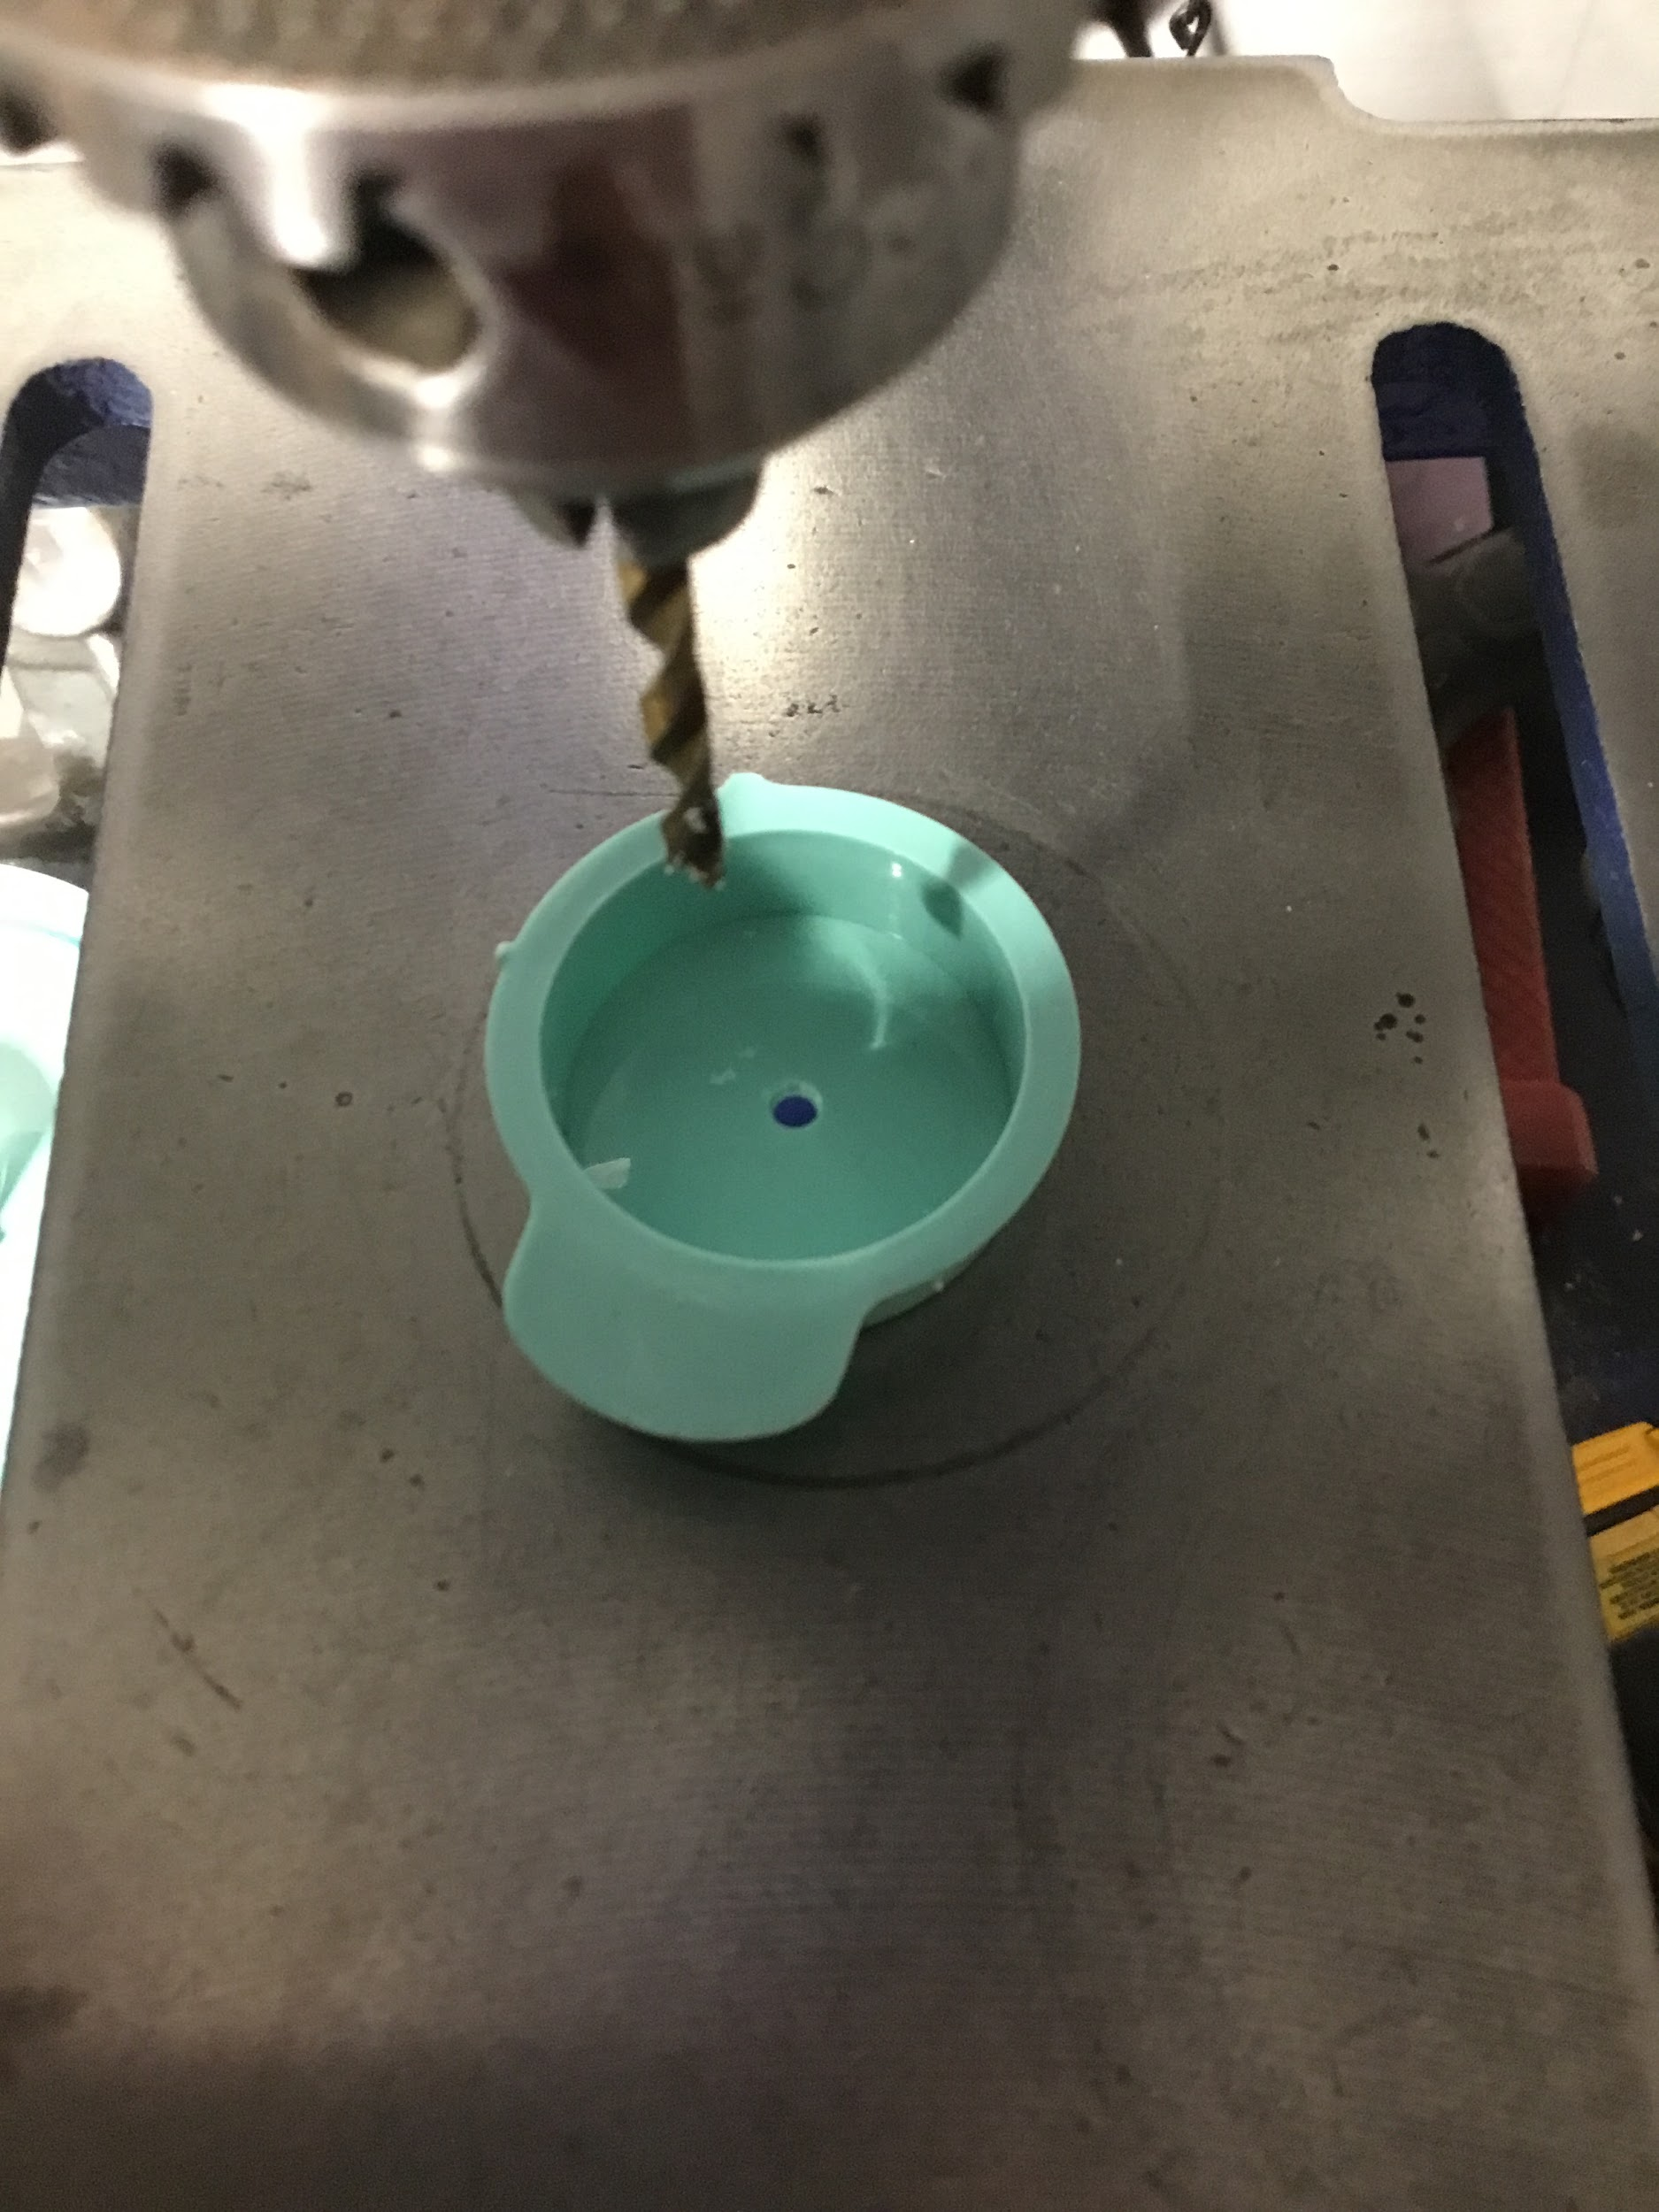

Step #2
- Flip the cap over and
- Grasp the cap with channel locks
- Drill a 1 ¼” hole
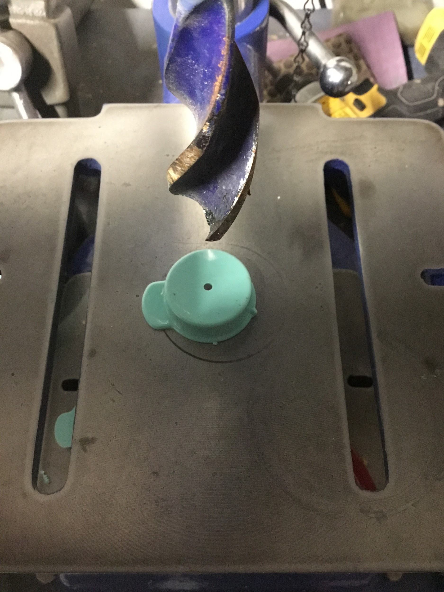

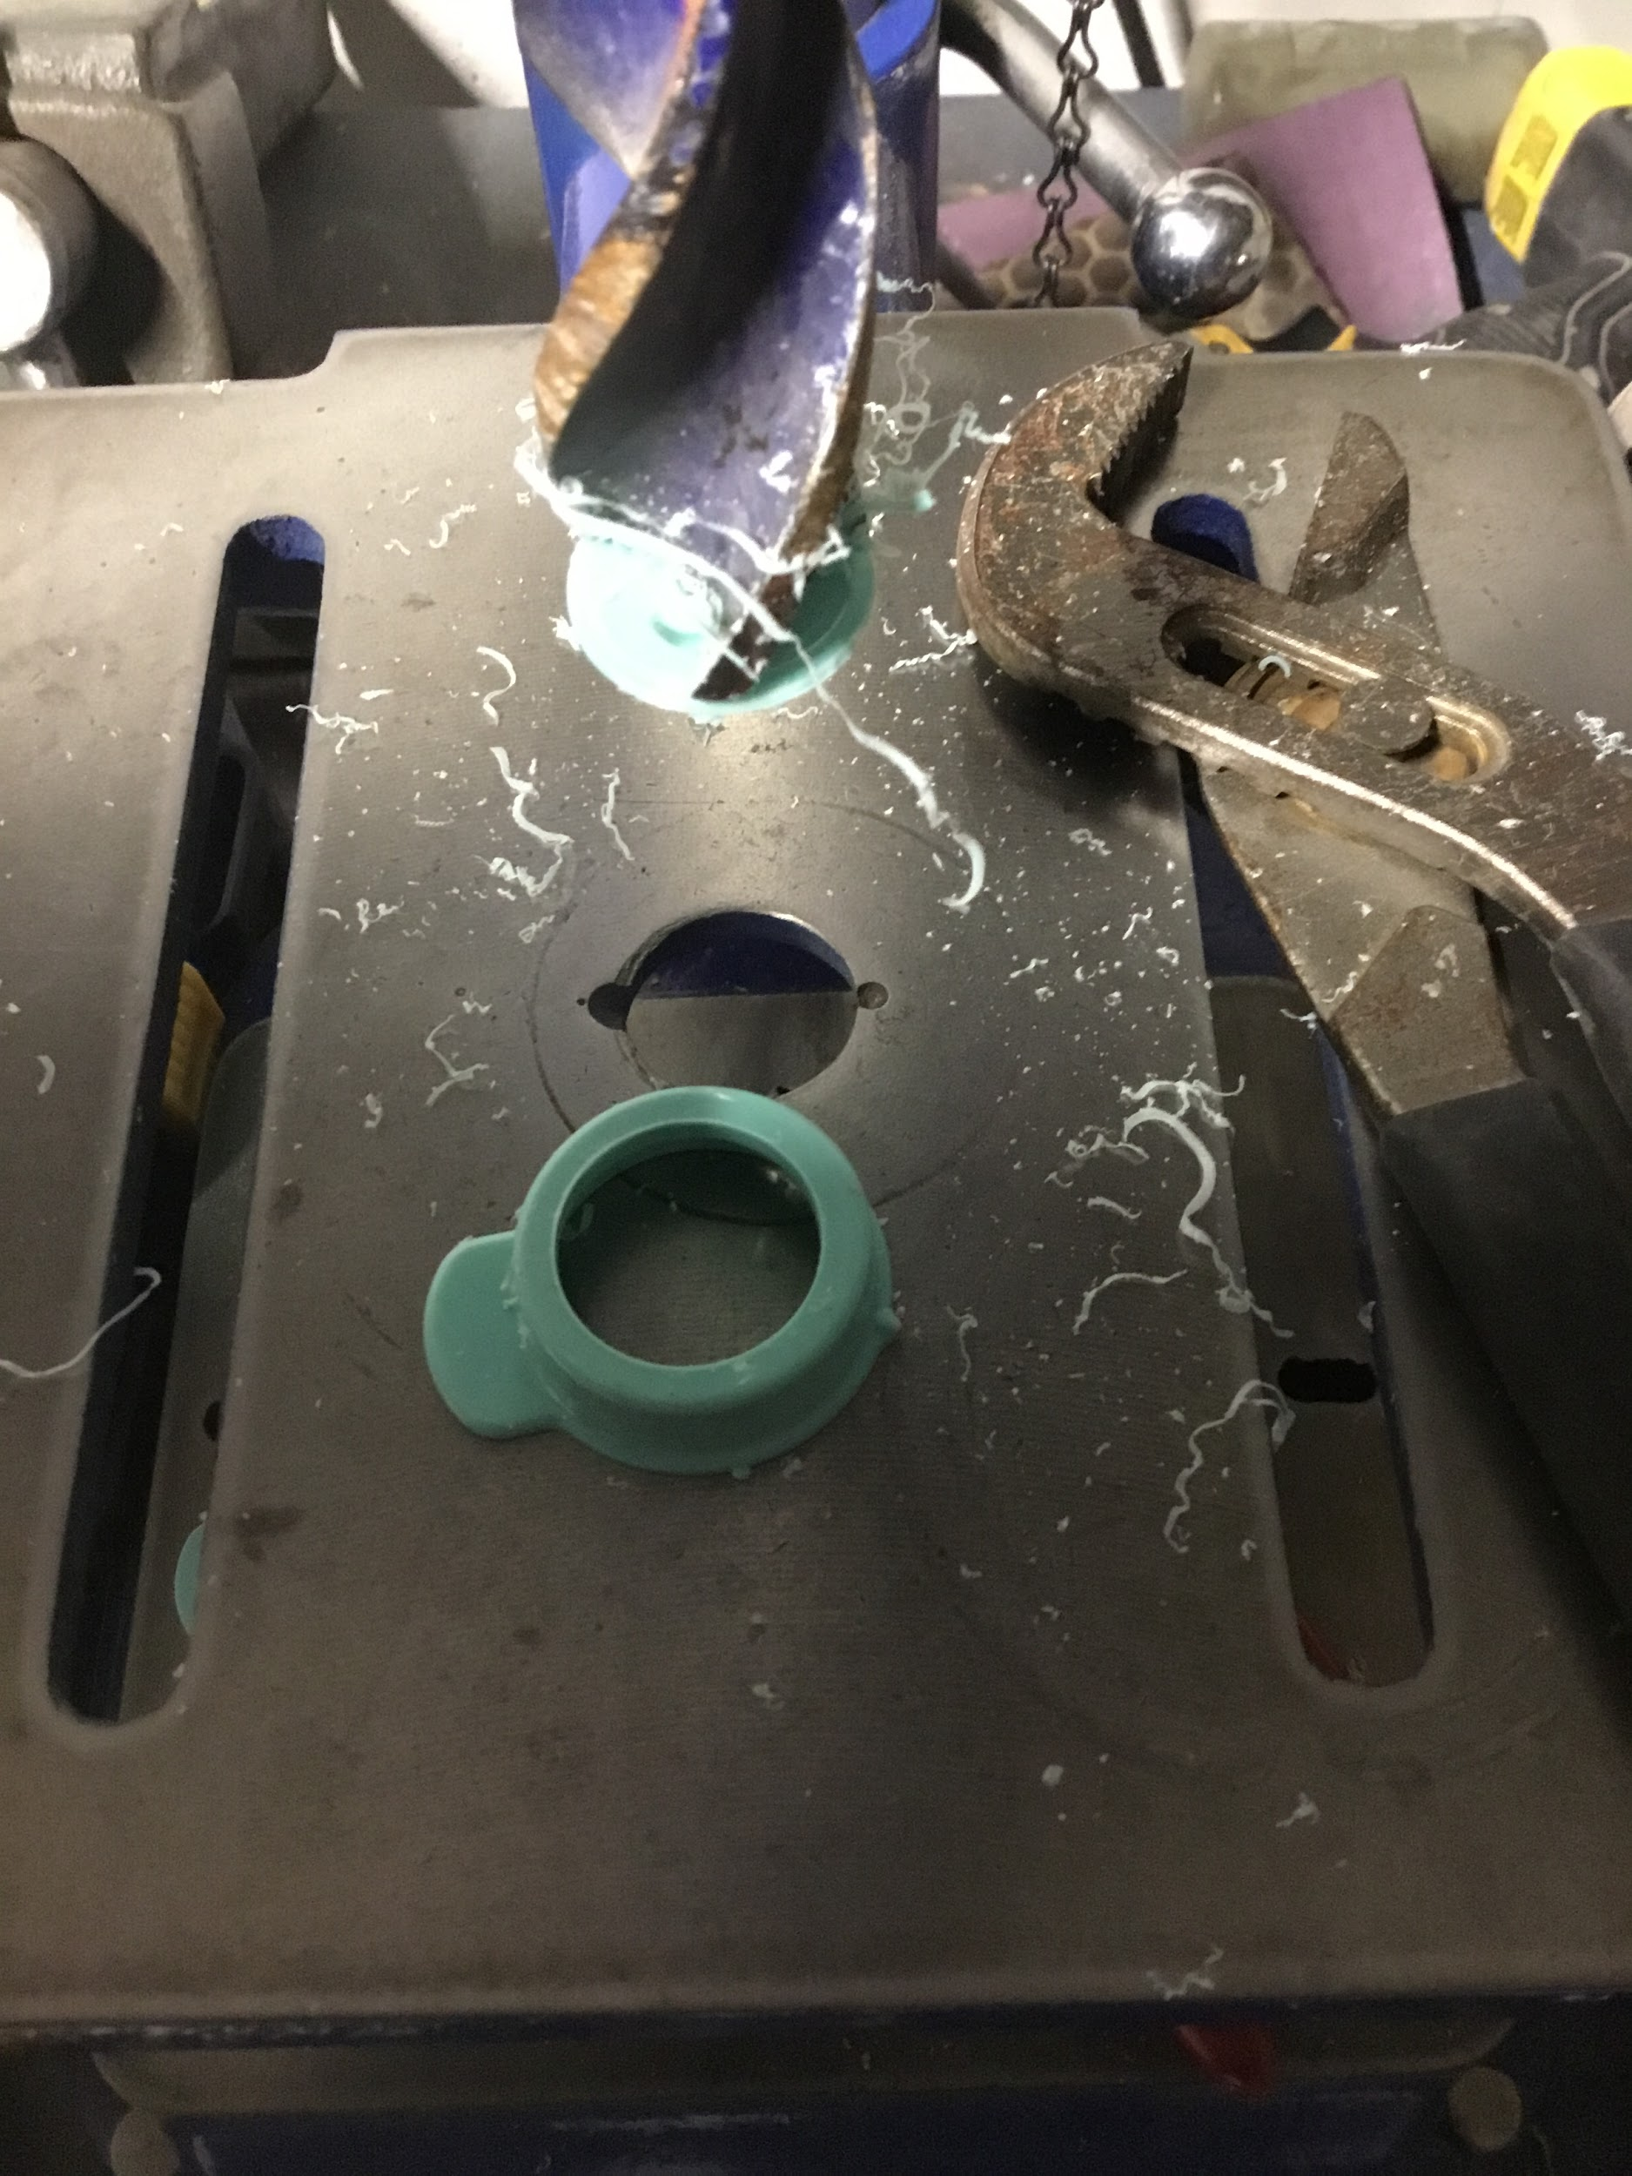

Step #3
- Completely disassemble the fluid pump

Step #4
- Note that the diameter of the pump base is larger than the inside diameter of the cap
- Gently sand the circumference of the white lip of the pump until it can fit inside the suction canister cap
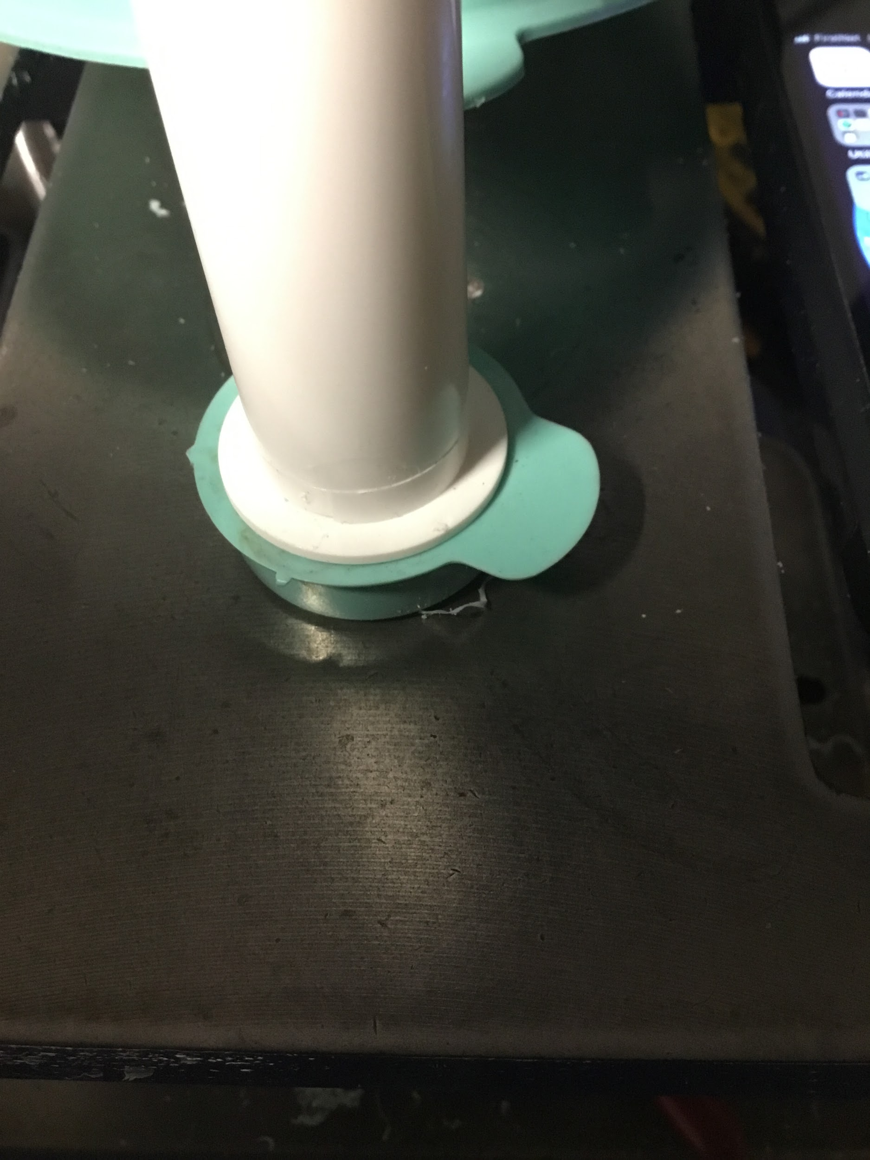

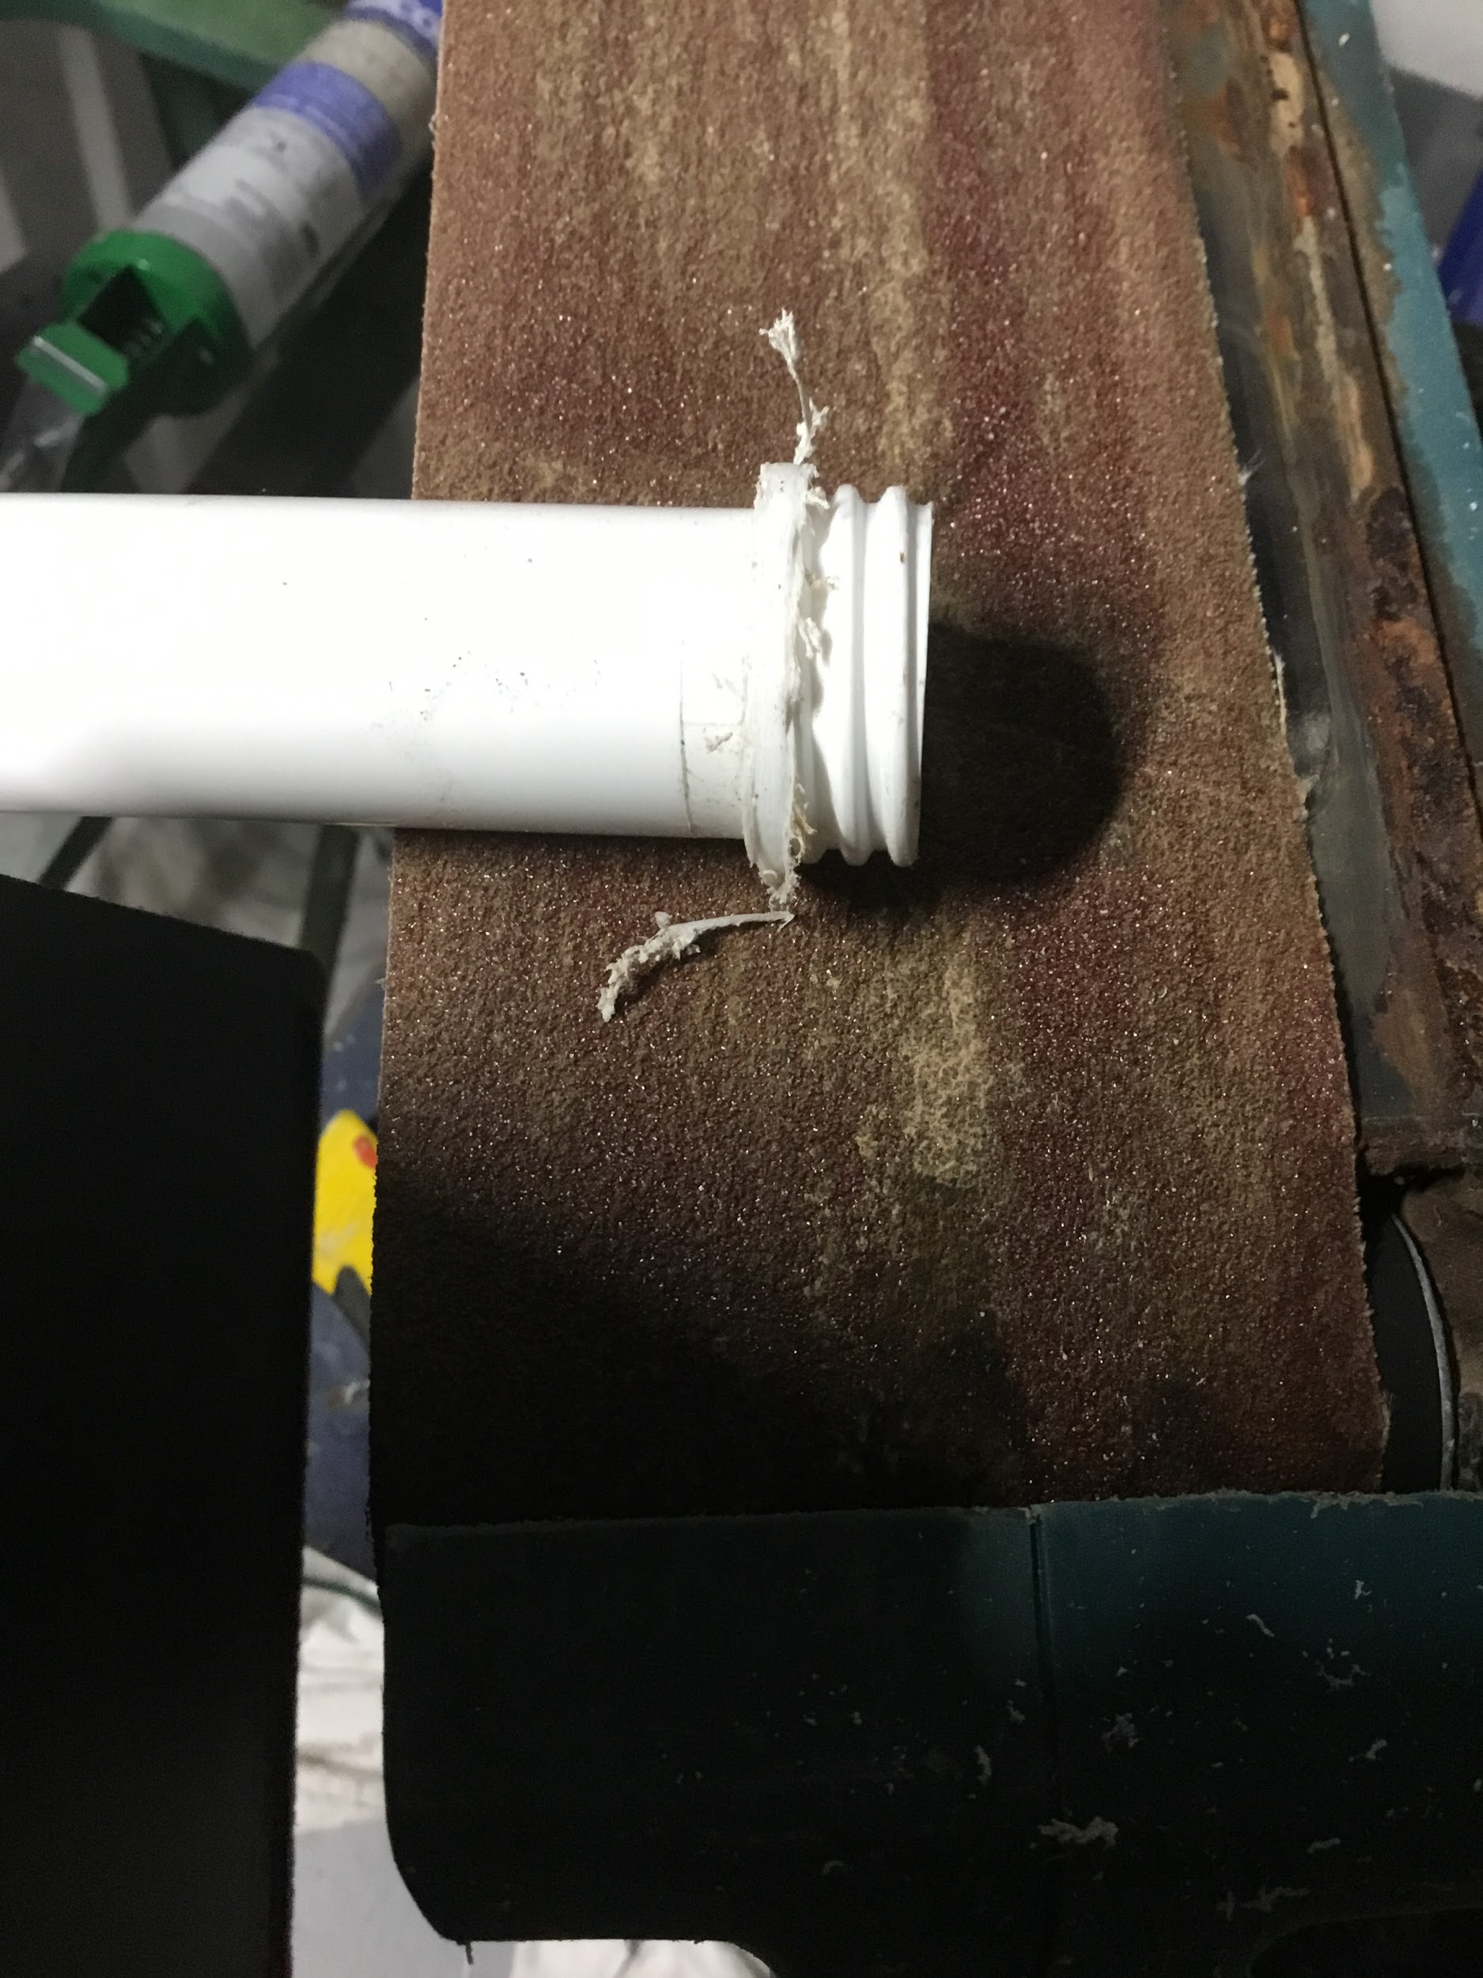

Step #5
- Reassemble the pump
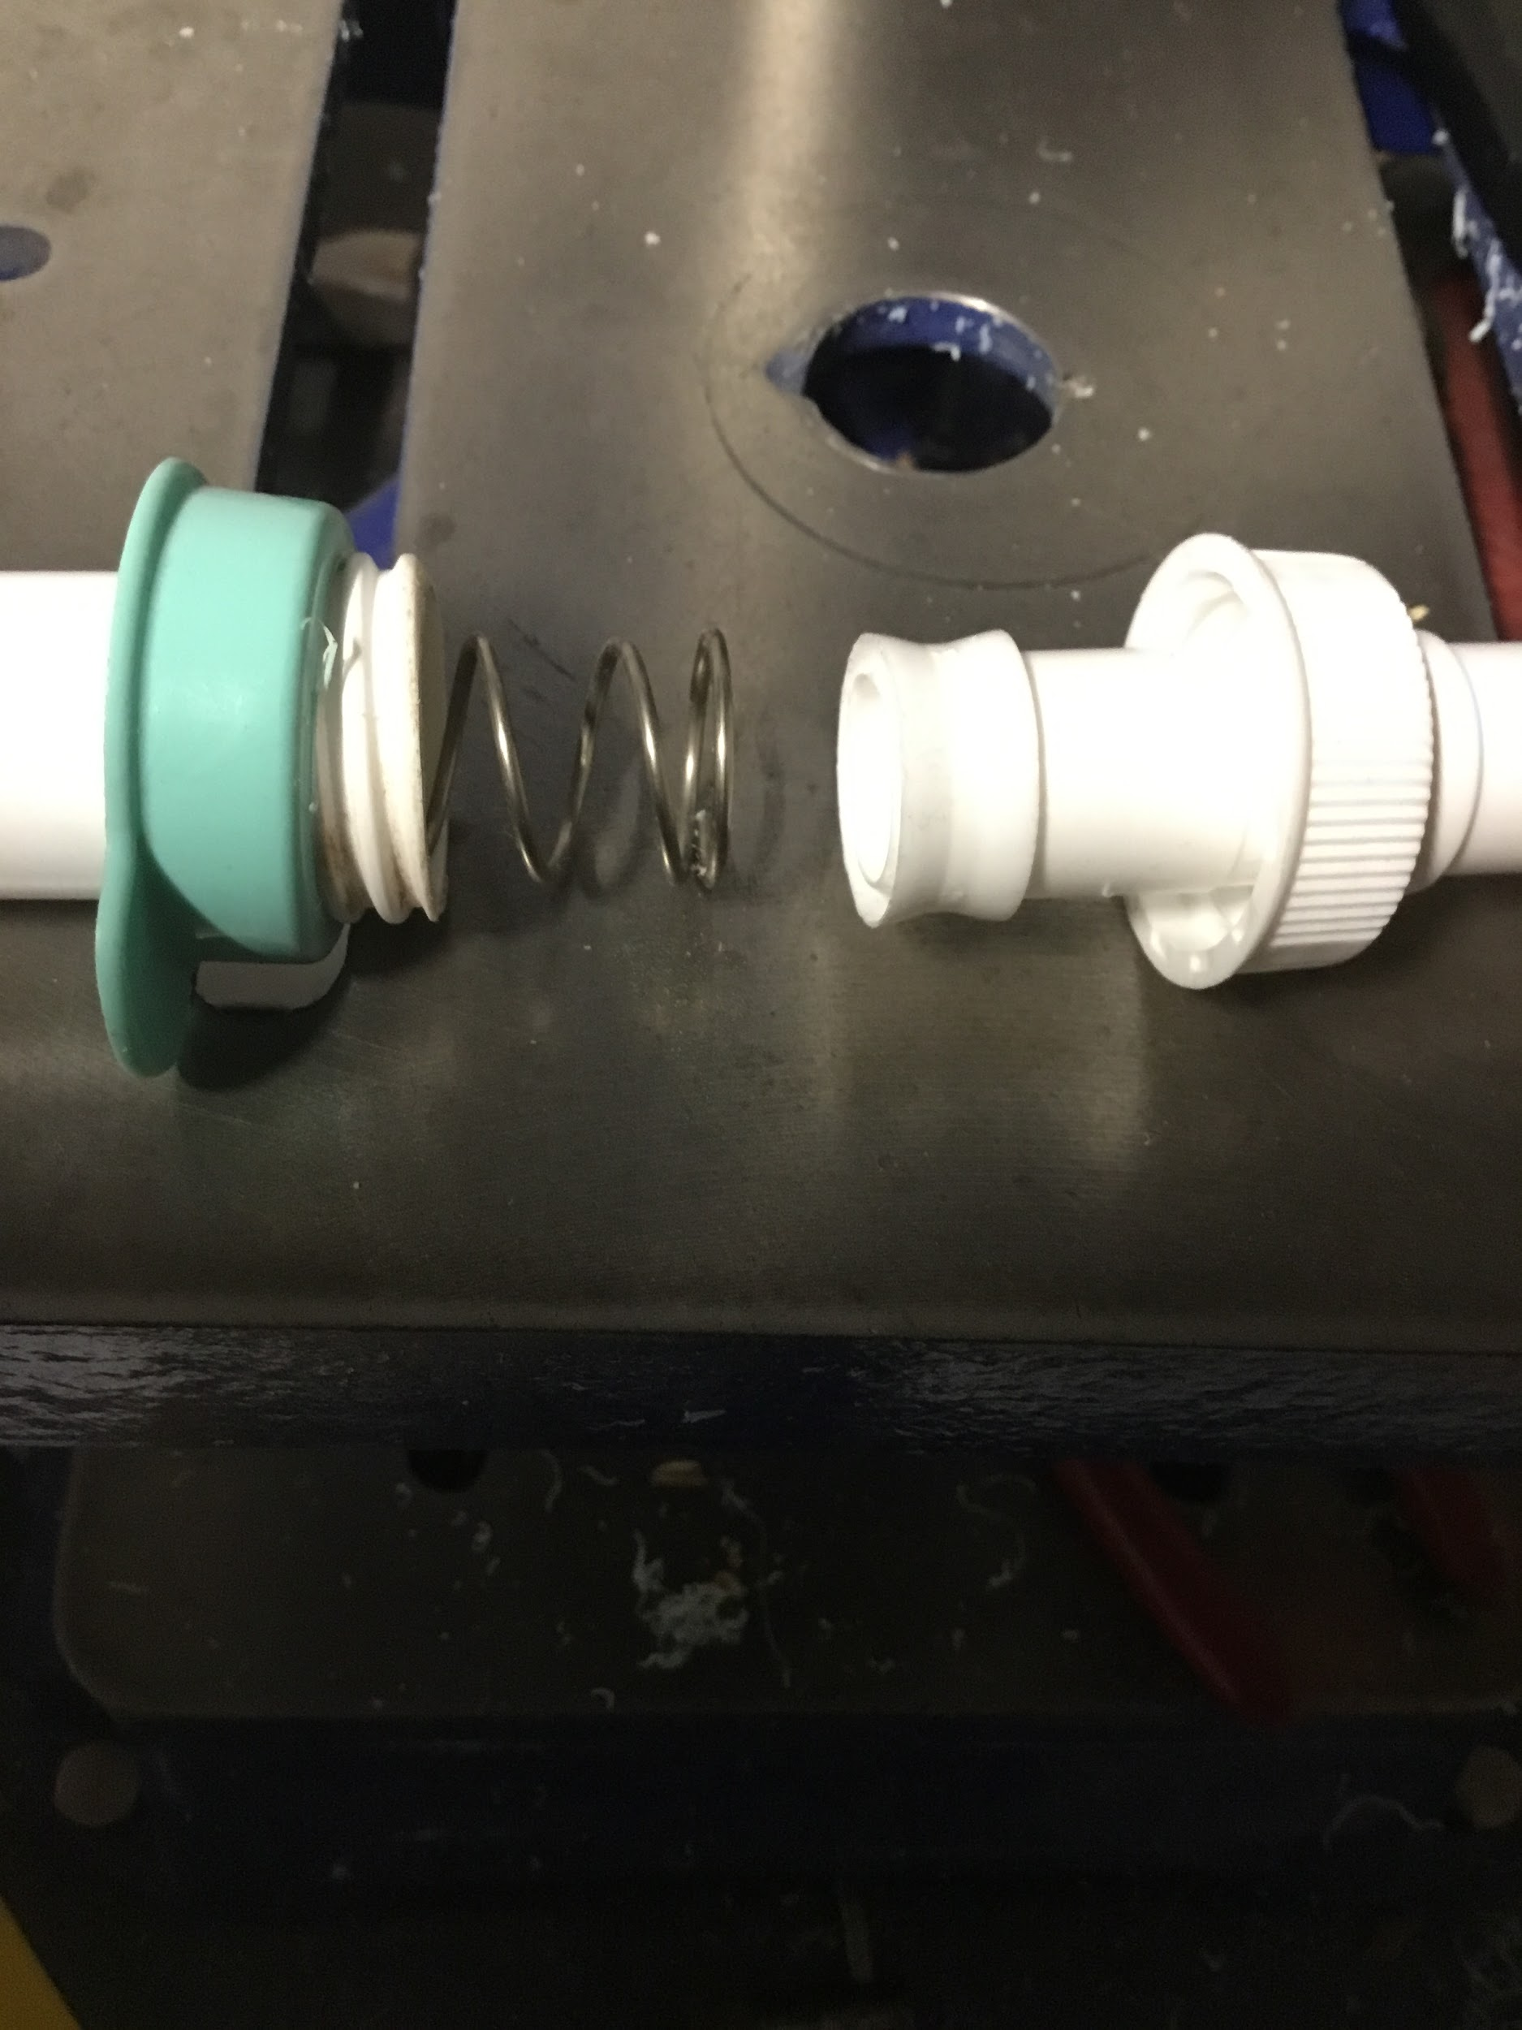

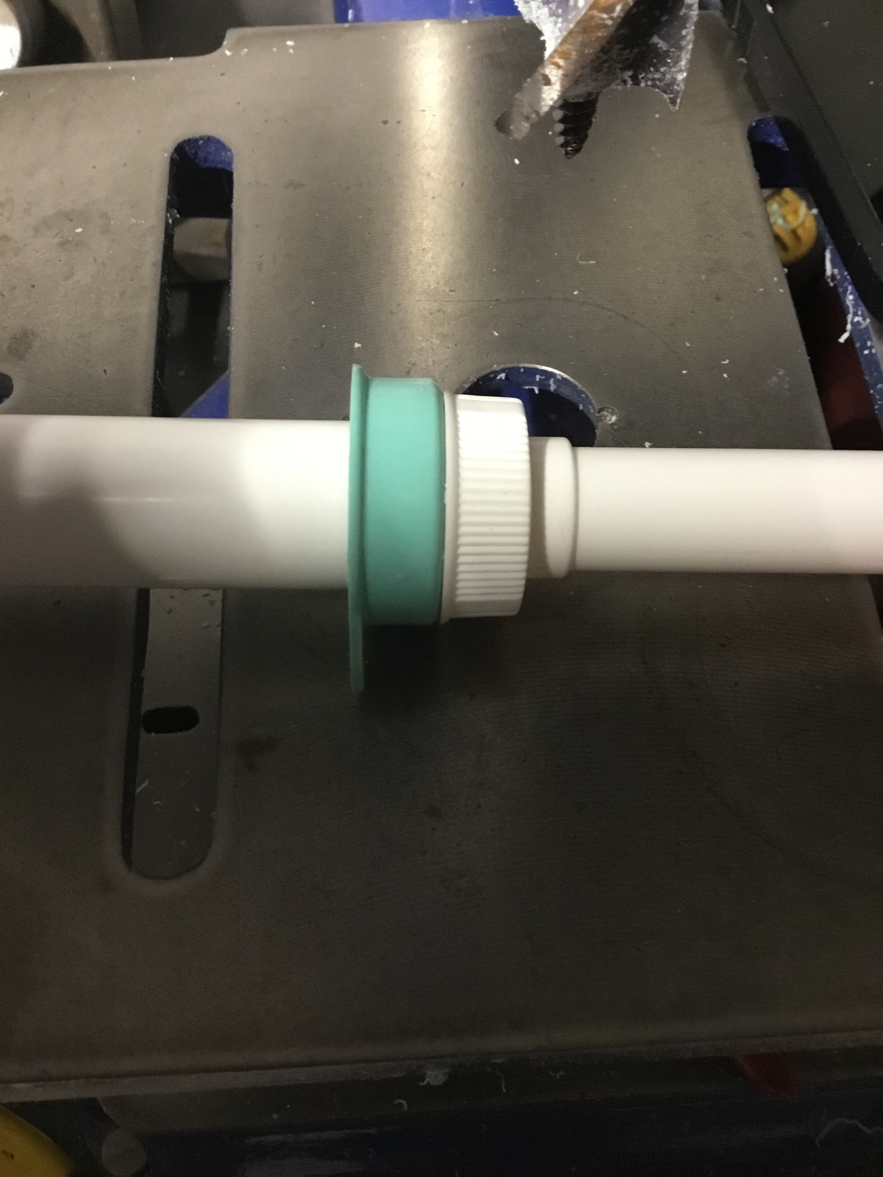

Step #6
- Note that the pickup tube is too large to fit the depth of a 1200cc suction canister
- Cut the pickup tube to the desired length. Approximately 2 ½”
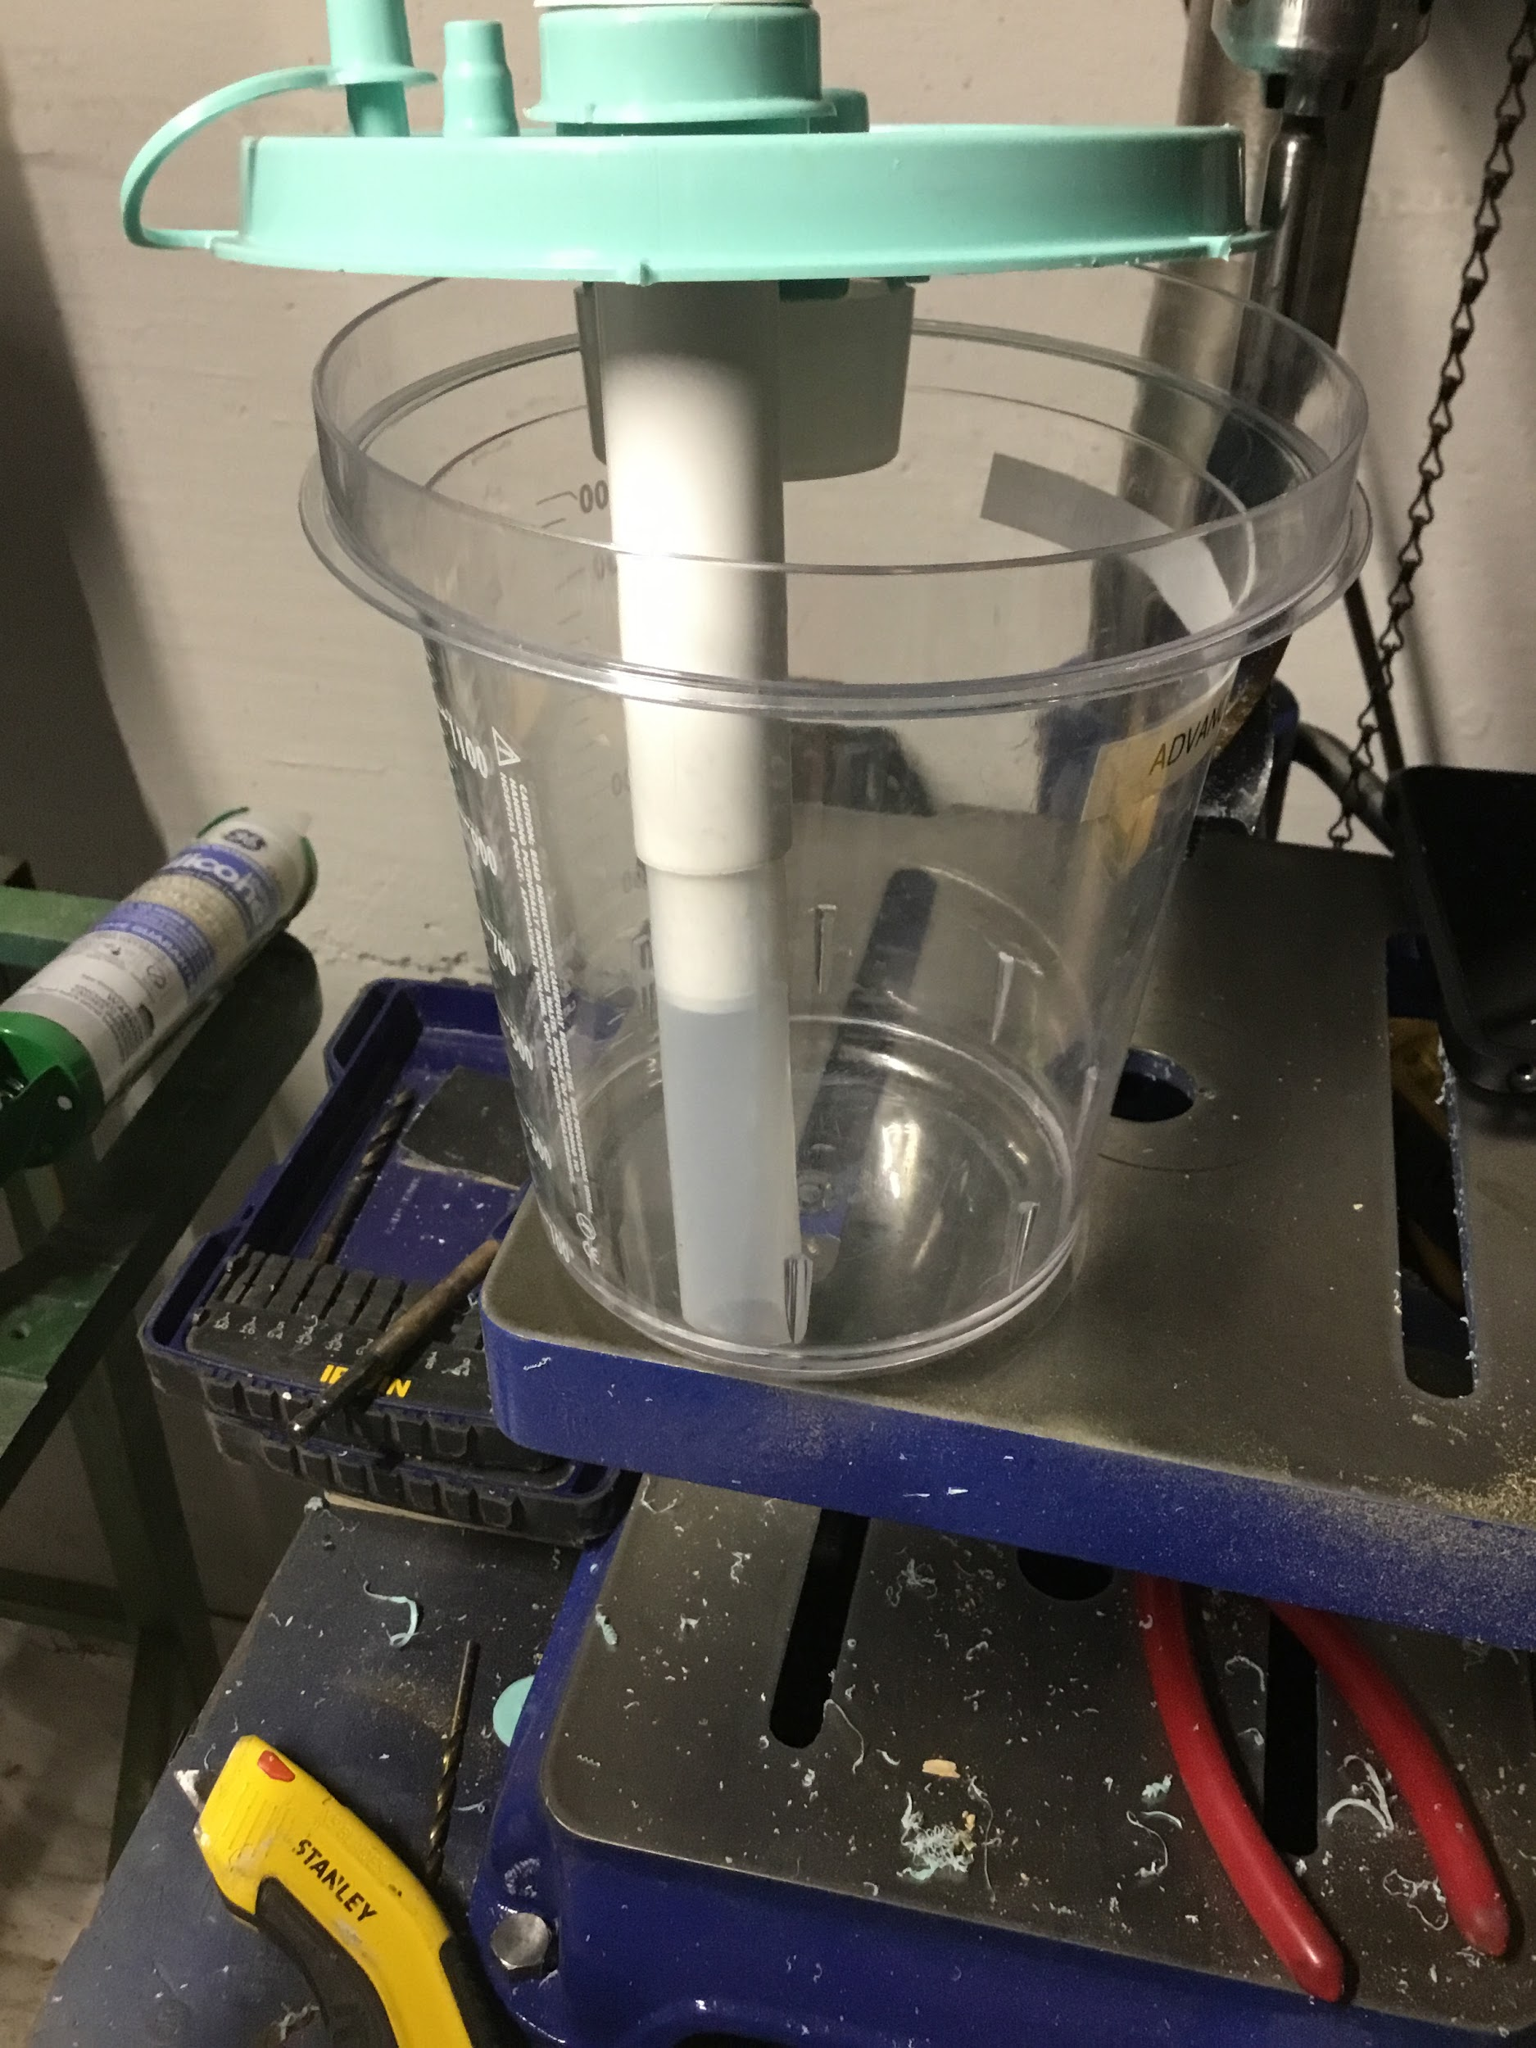

Step #7
- Train with your new set up

